**Introduction to Communications Cloud**

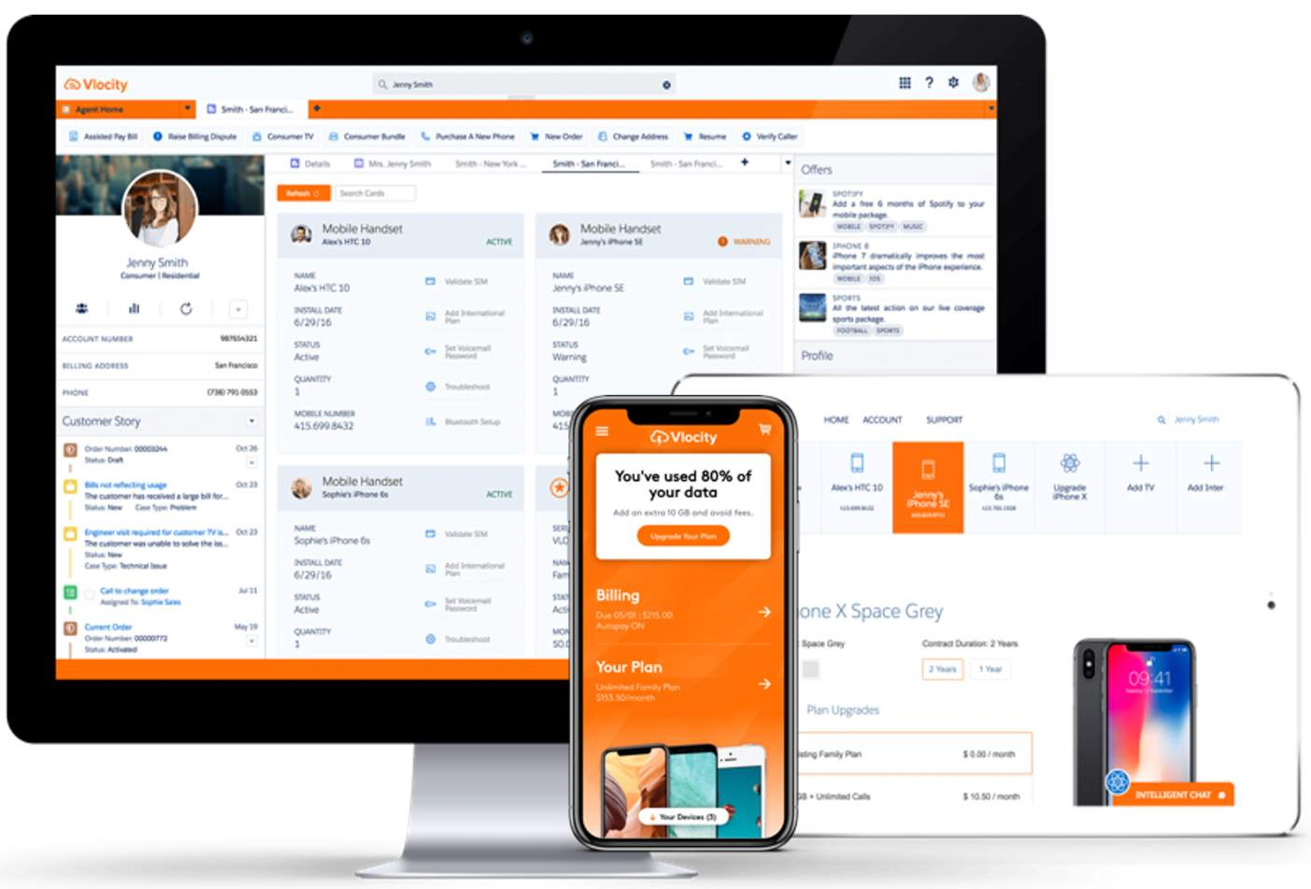

Salesforce's Communications Cloud is the industry’s most comprehensive, cloud-native BSS solution, giving you intelligent digital customer engagement and a next-generation user experience to walk customers and agents through complex ordering and fulfillment processes.

The Communications Cloud solves several industry challenges.

* Siloed systems

**Solution:**A Communications Cloud platform with a shared enterprise product catalog

* Slow CSR on-boarding

**Solution:** Rapid on-boarding of CSRs with Order Capture and Guided Selling

* Slow time to market

**Solution:** Fast time to market with the Enterprise Product Catalog (EPC)

* Low customer satisfaction

**Solution:**Satisfy customers with a fast, personalized shopping experience

* Disjointed customer experience

**Solution:**Give consumers a unified experience by positioning sales agents to be in-the-know about each customer

**Key Capabilities of the Communications Cloud**

**Intelligent Digital Customer Engagement**

The Communications Cloud works with Salesforce Einstein to provide intelligent digital customer engagement through a next-generation user experience to walk customers and agents through complex ordering processes using a conversational omnichannel user interface, whether on mobile, the web, or from the office desk.

The end-to-end, concept-to-care process begins with a product manager or marketing manager defining new products and offers for launch. With the Communications Cloud, you can enable operators to create quotes, capture and fulfill orders, and synchronize with third-party billing systems to process orders, start billing, and provide effortless care to customers through their channel and device of choice.

**Customer Lifecycle Management**

Supporting the full customer lifecycle, the Communications Cloud orchestrates quoting, order capture, billing, and service inquiry resolution across channels and devices. Users can view customer account relationships, active devices and services, billing, usage, and interaction histories for full awareness of the customer account and preferences.

**Shared Product Catalog-Driven Order Management and Fulfillment**

The Communications Cloud enables product-catalog-driven order capture and fulfillment, so that you can:

* Quickly design and launch new products and promotions.
* Change product prices dynamically, across sales channels, to respond to changes in the market.
* Create and manage customer contracts throughout the full contract lifecycle.
* Capture accurate quotes and orders for B2B and B2C accounts.
* Orchestrate order fulfillment and ensure timely service delivery using Industries Order Management.

**Industry-Specific Data Model**

The Communications Cloud industry-specific data model is compliant with TM-Forum standards and enables flexible integration with BSS/OSS. By extending the market-leading marketing, sales, and service applications of Salesforce with a communications industry specific data model, the Communications Cloud gives you powerful, digital-process-automation technology called OmniScript. You also benefit from a library of pre-built business processes and productized integrations, all of which are built in close conformance with TM Forum Frameworx standards.

Using the shared communications data model, the following components form the Communications Cloud solution:

* Industries Configure, Price, Quote (CPQ)
* Enterprise Product Catalog (EPC)
* Contract Lifecycle Management (CLM)
* Industries Order Management (OM)

Historical challenges of telcos include:

* **Siloed Systems:** Operators have built isolated systems stacks to support each discrete service they sell. Each system and associated user interface (UI) needs to be maintained and kept in sync with the other systems and UIs.
* **Lengthy on-boarding for new hires:** new sales and contact center agents typically spend weeks or months learning the dozen or so systems they need to use to interact with customers.
* **Extensive time to product launch:**It can take operators up to a year to launch new products and several weeks to launch a simple promotion.
* **Low consumer satisfaction:** Consumers rate most service providers at the bottom of industry satisfaction surveys.

**What's Happening Today?**

* **Transformation:**A growing majority of operators are starting to transform their business strategies from distributed, multi-stack systems to centralized systems designed for the digital age.
* **Re-invention:** Companies are re-inventing themselves as digital service providers by creating an agile, cloud-based, omnichannel customer engagement layer that delivers a consistent, effortless experience across all channels and devices.
* **Personalization:**The omnichannel engagement layer delivers personalized experiences powered by systems of insight, which are loosely coupled with operators’ traditional systems of record, for example, BSS and OSS.

What is the Communications Cloud?

A comprehensive suite of omnichannel CRM, retail, enterprise product catalog, configure-price-quote (CPQ), contract-management, and order-management applications.

What does it do?

Embeds processes built specifically for communications and media companies with guided-selling, service, and analytics functionality.

What else?

Enhances the B2B and B2C customer experience, enables revenue growth, and reduces cost to serve.

There's more?

Accelerates time to value, maximizes business agility, improves net promoter scores, and reduces the overall total cost of ownership for CRM deployments.

And with Salesforce...

100% native and 100% additive to Salesforce.

Salesforce's Communications Cloud brings a rich portfolio of products, processes, tools, assets, and analytical models to support your company’s digital transformation initiative.

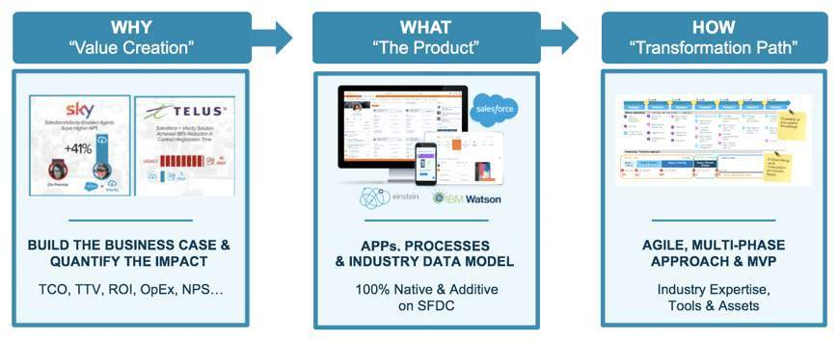

* The **WHY**: The experienced value assessment teams at Salesforce work closely with you to define strong business cases and justify digital transformation programs.
* The **WHAT**: The Communications Cloud helps you defend, differentiate, and disrupt in the digital economy.
* The **HOW**: The experienced delivery teams at Salesforce have developed a proven process for defining a successful digital transformation plan for your business.

**Types of Transformation**

**Engagement Layer Transformation**

Many customers begin their transformation programs by deploying the Communications Cloud as an agile customer engagement layer to improve lead and opportunity management.

**Line of Business Transformation**

The most common deployment mode of the Communications Cloud, this method often complements existing Salesforce B2B SFA (lead and opportunity management) with guided selling and service, CPQ, contract management, and order management.

The deployment typically starts by creating a 360-degree customer view, then strips sales, ordering, and service processes away from legacy applications. During this time, multiple legacy CRM, order fulfillment, sales and service portals are retired.

**Digital Operator Transformation**

Many operators, particularly mobile operators, are now launching new, mobile-first digital brands, supported by a new end-to-end, native cloud digital stack based on Salesforce, and Matrixx for online-charging and digital commerce.

# The Communications Data Model

The Communications Cloud data model supports all levels of product definitions, including offers, product specifications, services, and resource specifications. The Communications Cloud foundation takes into consideration all the business and customer data needed to solve the underlying issues affecting data quality and ensure the perfect order.

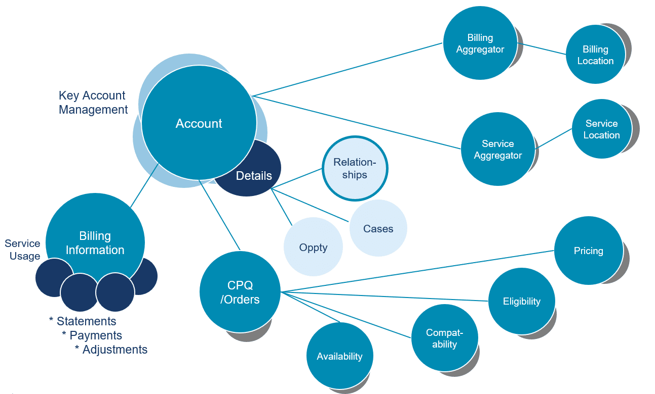

**Salesforce Industries Party Model**

The following diagram shows the main data elements in the Salesforce Industries Party Model.

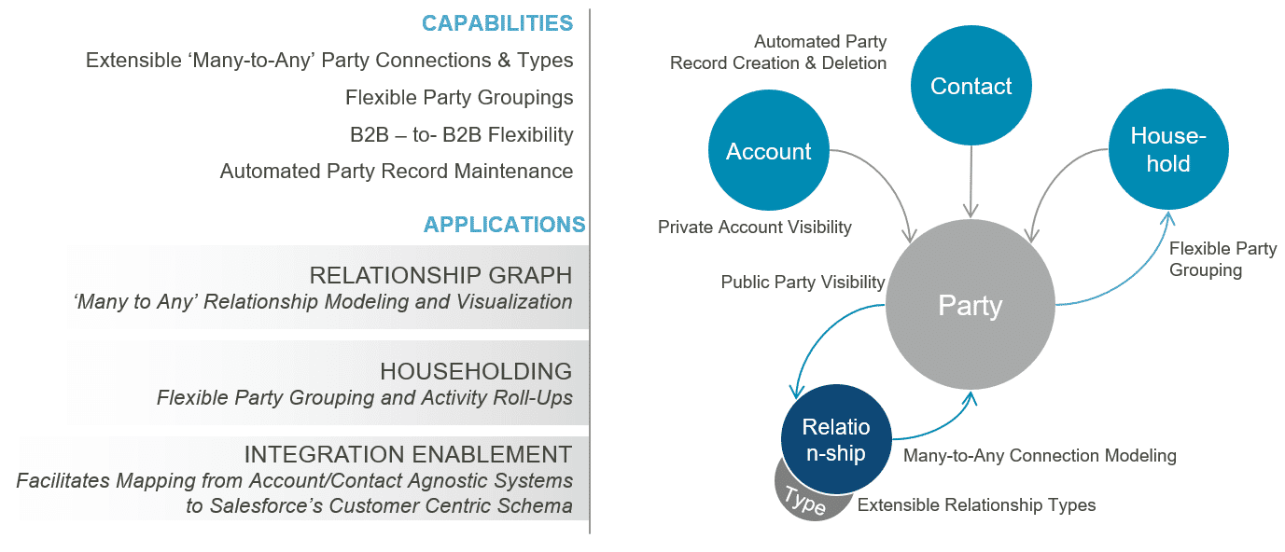

**Industries Party Model**

* The Industries party model is an important part of the Communications Cloud.
* Any entity with which a Salesforce customer does business is considered a party.
* All parties have a record in Party__c. People are stored in the Contact object, which is standard in Salesforce, while companies and other organizations are stored in the Company object.

**Account Objects**

* Salesforce Industries also uses the standard Account object. An Account record is created for any company, person, or other party who is a customer, client, or prospect.
* The Account record asserts the subset of parties that are considered relevant to sales and service. In multi-channel uses, the Account record separately asserts which parties are accounts to which of the internal or channel partner businesses. Therefore, if more than one internal or channel partner business considers the same party differently—for example, it's a customer to one and a prospect to another—they will each track that separately in their own Account records.
* The Account object has also been extended to address billing. The Communications Cloud is not a billing system, but the Bill Line Item object exists to hold billing information under certain circumstances.